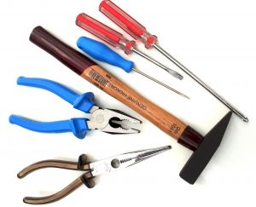

Home Remodeling Solutions

For A Free Estimate

Call: Richard Grunewald

303-489-5407 Cell

303-920-0310 Fax

